**Workbook Exercise: Building Bootstrap Layout (Containers, Grids, Columns)**

**Course:** Web Design Technology  
**Topic:** Bootstrap Layout – Containers, Grids, Columns  
**Instructions:** Complete the exercises below. Use Bootstrap to structure and style your layout.

**Exercise 1: Understanding Containers**

**Task 1: Create a Fixed and Fluid Container**

1. Create an HTML file.
2. Add Bootstrap via CDN in the <head> section.
3. Inside the <body>, create:
   * A **fixed container** (.container) with the text: "This is a fixed container."
   * A **fluid container** (.container-fluid) with the text: "This is a full-width fluid container."

**Expected Output:**

* The fixed container has **padding** and a **max-width**.
* The fluid container spans **full width**.

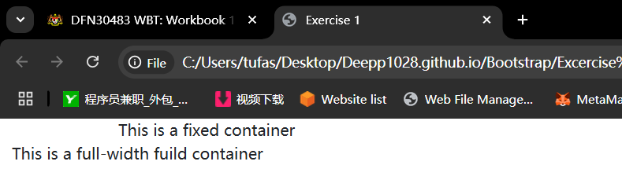

**Exercise 2: Using Bootstrap Grid System**

**Task 2: Create a Two-Column Layout**

1. Inside a .container, create a .row.
2. Add **two columns** of equal width using .col-6.
3. Add some content inside each column, such as:
   * "Column 1"
   * "Column 2"

**Code Starter:**

Fill in the missing parts of this code:

<div class="container">

<div class="row"> <!-- Row -->

<div class="col-md-6">Column 1</div> <!-- Column -->

<div class="col-md-6">Column 2</div> <!-- Column -->

</div>

</div>

**Expected Output:**

* Two equal-width columns displayed side by side.

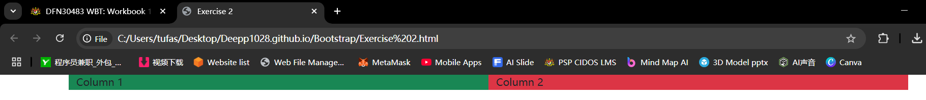

**Exercise 3: Creating Responsive Columns**

**Task 3: Build a Responsive Layout**

1. Create a .container.
2. Add a .row.
3. Create **three columns**:
   * On **small screens** (col-sm-12), each column should take full width.
   * On **medium screens** (col-md-4), each column should take one-third of the row width.
4. Add sample content inside each column.

**Expected Output:**

* Columns **stack on small screens** and **appear side by side on larger screens**.

**Question:**

Which Bootstrap class should be used for small screens to make each column full width?

Class=”col-sm-12”

Big screen

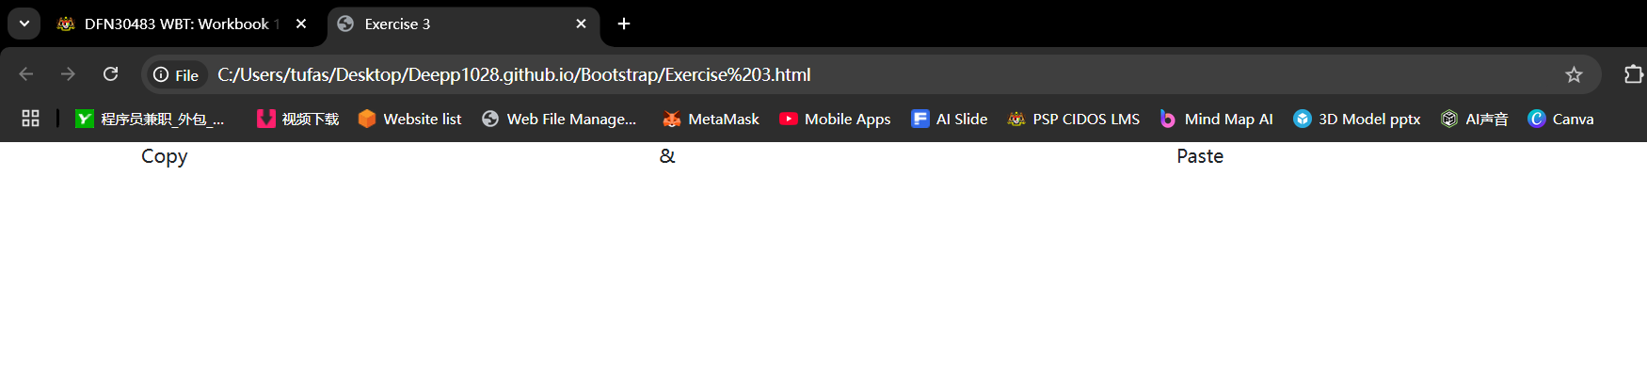

Small screen

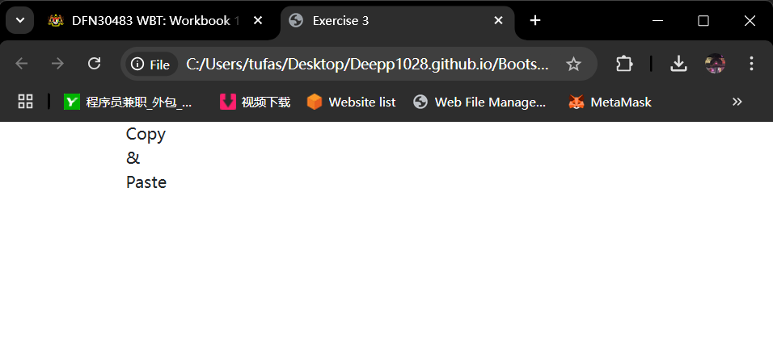

**Exercise 4: Using Column Offsets**

**Task 4: Center a Column**

1. Inside a .container, create a .row.
2. Create a single .col-md-4 column.
3. Use **offset classes** to center it on medium screens (offset-md-4).
4. Add text inside: "Centered Column".

**Fill in the Blanks:**

<div class="container">

<div class="row">

<div class=“col-md-4 offset-md-4“Centered Column</div>

<!-- Offset Column -->

</div>

</div>

**Expected Output:**

* A **single column** centered in the middle of the row.

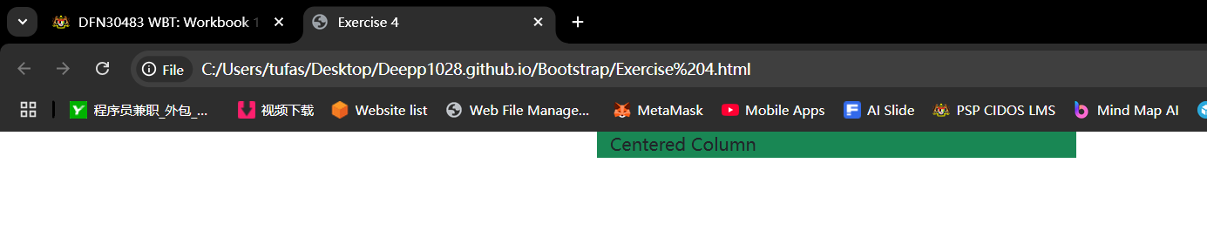

**Exercise 5: Nesting Columns**

**Task 5: Create a Nested Grid**

1. Inside a .container, create a .row.
2. Add a .col-md-6 column.
3. Inside this column, create a **new row** with **two equal-width columns** (col-md-6).
4. Add content inside the nested columns:
   * "Nested Column 1"
   * "Nested Column 2"

**Expected Output:**

* A **main column** that contains **two smaller columns** inside.

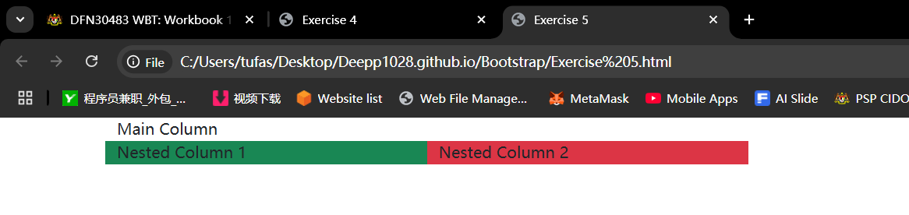

**Bonus Challenge: Full Page Layout**

**Task 6: Design a Simple Web Page Layout**

Using Bootstrap, create a **basic webpage layout** with the following sections:

| **Section** | **Grid Layout** |
| --- | --- |
| Header | Full width (col-12) |
| Navigation | Full width (col-12) |
| Main Content | Takes **8 columns** (col-md-8) |
| Sidebar | Takes **4 columns** (col-md-4) |
| Footer | Full width (col-12) |

Use appropriate **Bootstrap grid classes**. Add some placeholder content.

**Submission:**

* Save your HTML file as bootstrap_layout.html.
* Ensure your code is properly indented and formatted.
* Submit your completed workbook with **screenshots of your output**.

